

Newsletter – Westview Christian Church

**(Disciples of Christ)**

**The Rev. V. J. Stover ,**

**Interim Senior Minister**

**5925 W. 34th Street, Indianapolis, IN 46224**

**317-291-7871**

**September 2019**

*Minister's Moment*

I have quieted my Facebook wall by snoozing all diatribes that have been reposted by someone else. These reposts are not original to the friend who has posted them but are sourced from dubious second and sometimes third-party sources. In effect I have eliminated fake news, phishing news, and virus-infected news. It has quieted the emotional content of my wall and my life.

A CONSEQUENCE of my CHOICE to do this is that my wall has become more spiritually uplifting and challenging. What follows is some of the things that have caused me to think about my faith, my relationship with God and others, and what I want my life to be like.

First, “You are free to choose, but you are not free from the consequence of your choice.” I find this is one of the foundation stones of Paul’s systematic thought in the Book of Romans where Paul defines the wrath of God as being left to the consequences of our choices to sin. It is not fire and brimstone, or some Dante-esque retribution in Hell. The consequences of sin in this life are real and we are left alone to them. But when we choose God, God says, “You are not alone. I can take care of that for you. We’ll see this through together.”

Second, “When we pray, ‘let your kingdom come,’ we are likewise praying, ‘let my kingdom go’.” Interesting take on what humility is for often we are praying something like “Please, God let me win that lottery so I can show you just how good a Christian I can be.” If we can’t be good in the small things we have received in abundance, how can we possibly think we can be good in the huge thing?

Third, “There are 3 C’s in life: Choices, Chances, Changes. You must make a CHOICE to take a CHANCE or your life will never CHANGE.” The pitfall here is to think that life never will change if we make no choice to take a chance. However, life is constantly changing whether we make a choice or not. Our task as faithful people is to embrace the change and always look for God in it.

Can you see how these first three are intertwined with one another?

Fourth, “Did I offer peace today? Did I bring a smile to someone’s face? Did I say words of healing? Did I let go of my anger and resentment? Did I forgive? Did I love? These are real questions.” These were posed by Henri Nouwen, a 20th century theologian and psychiatrist. At the end of the day these are good review questions. At the beginning of the day, they could be a help to keep us focused on our mission in faith.

In the end for me there is a summation in a fifth altruism: “There is no perfect life, no perfect job, no perfect childhood, no perfect marriage, and no perfect set of people who will always do what we expect them to do. What we have is a perfect God who is able to lead us through this imperfect life with unfailing strength, incomparable wisdom, and infinite love.”

Facebook can be up-lifting, it is my choice of what I gather and what I sow.



**FROM THE MODERATOR**

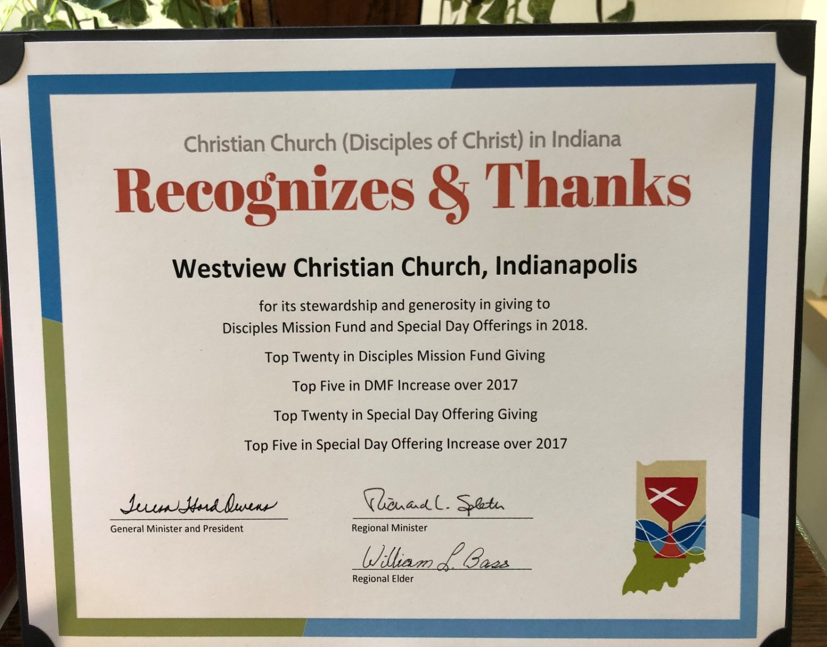On August 12, William Bass, our Regional Elder, presented Westview with a certificate for our generous contributions to many Disciples funds.

Since the Board did not meet this month and we did not have a joint meeting, there is little to report. However, coming in September will be the creation of the Nominating Committee who will be looking for people to serve next year in various activities for the Church. Please be ready to help us continue our mission. The Board will meet next month and there will be more then. Please enjoy the warm weather as the summer begins to end.

Joe Lawson



**ELDER’S CORNER**

**Greetings WCC FAMILY and FRIENDS! It’s a great day. Thank You Lord!**

Father, thank You for Your Word which is a lamp to my feet and a light to my path. I choose to hide Your Word in my heart. I choose to meditate on Your promises. I know that You are faithful to Your Word and thank You for rock-solid faith as I keep my heart and mind focused on You in Jesus’ name. Amen. Love you all!

❤ Submitted by Rev. Mackcine Jordan

**OUTREACH** **COMMITTEE**

**FAMILY PROMISE CHANGES**

**SAD, UNFORTUNATE AND DISAPPOINTING NEWS FOR THE SPEEDWAY AREA**

Family Promise has notified us that the week of Sept. 22, Speedway United Methodist Church will be the next to host families in the Speedway area.  The fourth week of December, at St. Gabriel Catholic Church will be the last Family Promise week hosted by the Speedway Ministerial Association. Lack of support from our congregations and failure to find a Speedway area coordinator has made this necessary.  Family Promise thanks Westview, noting that we have helped to make a "tremendous difference in the lives of children and adults".

**VOLUNTEERS NEEDED AT**

**LEW WALLACE SCHOOL #107**

For a number of years Westview has volunteered to assist students at nearby Lew Wallace School who are below their grade level in reading and math.  It is a critical ministry to the children's futures  And, it’s rewarding and much appreciated by both students and faculty who are very flexible in meeting your schedule for day and time.  They're open to having assistance one hour a week, or every other week or once or twice a month,  And we don't all have to be there on the same day, or at the same time.  If you, or a friend might have an interest in this Westview ministry to local children, contact the church for more information.

**DIRECTORY UPDATES**

Email update for The Storehouse Food Pantry: [rhoerger@mac.com](mailto:rhoerger@mac.com)

Bill Bass was our *temporary* Regional Elder. He is now the *permanent* Regional Elder.

**COOKING CLASSES**

We will be offering cooking classes at the Church. They will be for four weeks in September, four weeks in January and four weeks in April-May. They are open to everyone. September classes are September 7, 14, 21 and 28 at 9:30 am.

Hope to see you there. We always have a lot of fun!

Contact Mary Chittenden by calling the church to sign up, there’s still time.

**PRISCILLA CIRCLE STARTS IN SEPTEMBER**

Calling all Westview women......Mark your calendars.  Our first meeting will be on Saturday, September 14, from 10:00-11:30.  We meet at the church.  Our study books are here and the theme for this year is: “***The Church on a Mission”.*** Please consider coming as often as you can this year......the second Saturday each month. Enjoy lively discussions, Bible study, prayer, deepening our spiritual life, and getting to know each other through our time together.

Questions?  Contact Sylvia Mill or Ethel Cline by calling the church.

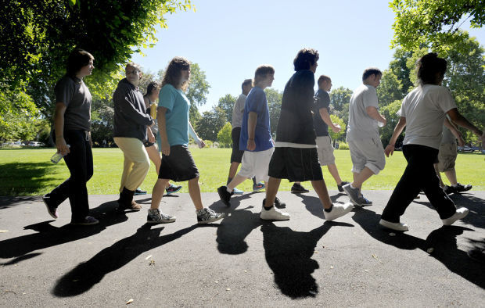 **2019 CROP WALK**

The 2019 CROP Walk will soon be upon us!  The CROP Walk will be held onOctober 6, 2019 at

1 pm.  The distance of the walk is 3.5 miles. If you can’t walkthat distance or if you have a schedule conflict for that date, you can still support the cause of ending hunger by financially supporting our team of walkers!  Pastor VJ is the team captain for Westview Christian.  In the weeks ahead there will be ample time to become a sponsor or a walker or both!  There will be sign-up sheets as in years past, or you may go to: <https://www.cropwalk.org/indianpolisin/TeamView/113656/Westview-Christian> and register or donate on line.  Our goal is to raise $1000, or more to help with local food pantries.

**THANK YOU WESTVIEW!!!**

The items you donated to "*Purchased"* during May/June have been delivered.  Jessica Evans, Director, expressed deep appreciation on behalf of this organization that focuses on supporting victims of sex trafficking and raising awareness in our community of this issue.  Toiletry items, notebooks, and lots of snacks, plus a check for $65 were donated.  Thank you again for your generous response.  If you have any questions about this organization and its work, please contact the church office.

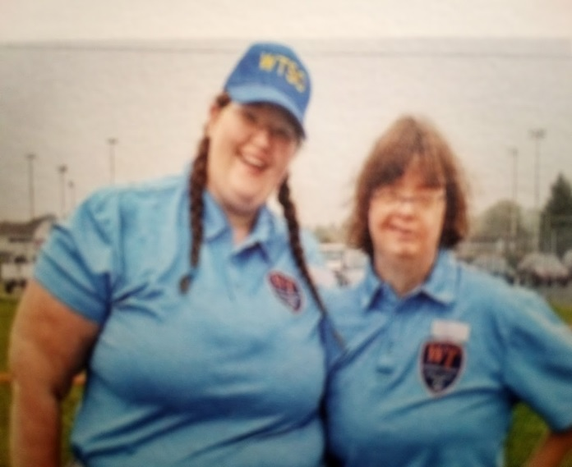

**THANK YOU WESTVIEW FROM WASHINGTON TOWNSHIP SPECIAL OLMPICS**

“Thank you all, and Stuart Mill for this generous donation. Our friends mean so much to our programs.”

|  | **SEPTEMBER 2019** | | | | |  |
| --- | --- | --- | --- | --- | --- | --- |
| **Sun** | **Mon** | **Tue** | **Wed** | **Thu** | **Fri** | **Sat** |
| **1**  9:30am Sunday School  10:30am Worship | **2**  Office Closed | **3** | **4** | **5** | **6**  IHS – Fellowship Hall, decorating in the afternoon | **7**  IHS – Fellowship Hall and downstairs Sanctuary, 5:30 pm |
| **8**  9:30am Sunday School  10:30am Worship  Elder’s Mtg. after Worship | **9** | **10**  Board Mtg.,  7:00 pm | **11** | **12** | **13** | **14**  Priscilla Circle 10:00am |
| **15**  9:30am Sunday School  10:30am Worship | **16** | **17**  Lunch Bunch  MCL – 11:30am | **18** | **19** | **20** | **21** |
| **22**  9:30am Sunday School  10:30am Worship | **23** | **24** | **25** | **26** | **27** | **28** |
| **29**  9:30am Sunday School  10:30am Worship  5th Sunday Pitch-In | ***30*** | **1** | |  |  |  |  |  | | --- | --- | --- | --- | --- | | **2** | **3** | |  |  | | --- | --- | | **4** | **5** | | | | | |

**VISIT OUR WEBSITE:**

[**www.westviewchristianchurch.org**](http://www.westviewchristianchurch.org)

**Join us on Facebook**

**Westview Christian Church, Indianapolis**